Case History: Lead Zinc Targeting using EmPower™ Helicopter Time Domain Electromagnetics
In this example in volcanics, there is known lead (pb) and zinc (zn) mineralization located below 95 m of weakly conductive overburden. The mineralization has a similar (low) conductance and therefore, corresponding low-amplitude profiles.
The object of the survey was to map the extent of the mineralization (unknown at the time) and identify the strike and dip directions as well as the exact drill targeting locations. Previously this zone was only seen with the CSAMT method.
Terraquest’s EmPower™ helicopter time domain EM survey was the source of data shown in this case history. A loop recorded time domain electromagnetic data at a range of sampling times, up to 600 microseconds. The background resistance in the area is relatively uniform at 200 ohm-m.
Putting an EmPower™ EM Survey into Action for Base Metals
In working on the project, Terraquest’s survey design personnel were led by several factors including the effectiveness of helicopter time domain electromagnetics for investigating deep and shallow targets mineralized with sulphides.
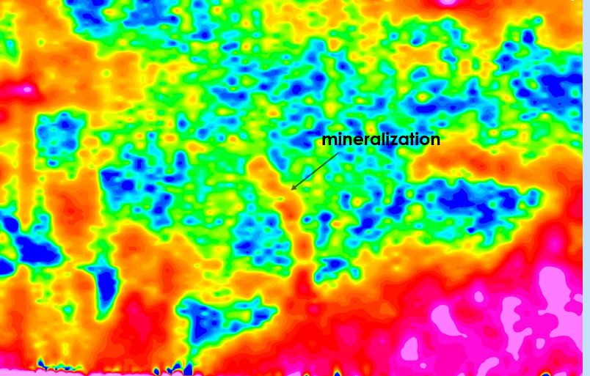
Figure 1: Outline of Mineralization Emerging from Background at Z Channel 6
We can see that drill targets are already emerging. In the image below, we see time constants for sulphide-bearing rocks in the area with high times indicating persistent sulphide-rich mineralization.
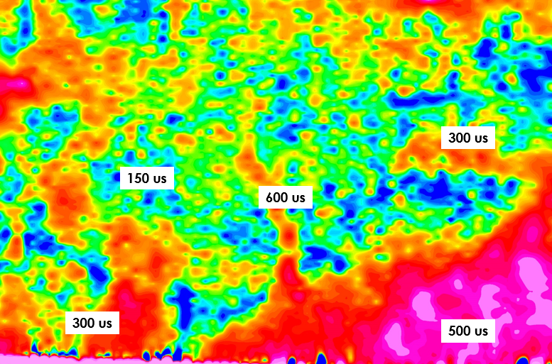
Figure 2: Time constants for the survey. Mineralization has a time constant of 600 us.
The specific results are that:
- Drill targets are located correctly over the 600 microsecond body.
For More Information
Terraquest would be pleased to discuss EmPower™ helicopter time domain electromagnetic surveys and interpretation approaches with you, including inversions of existing or planned data. For more information, click here <LINK to EASY-QUOTE form>.

